https://www.see-nl.com/artikel/20240311-the-dutch-line-up-at-cphdox-2024

The Dutch line-up at CPH:DOX 2024
CPH:DOX is running from March 13 to March 24
13-3-2024 09:00

A wide range of docs from the lowlands will be shown at the Danish documentary festival.

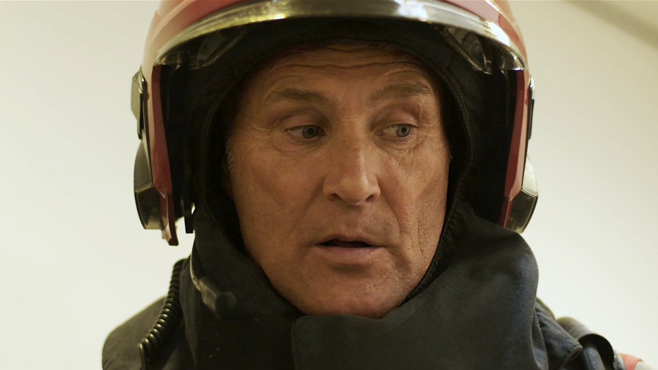
Still: Burning Out - Saskia Gubbels

Part of the Urgent Matters section is Saskia Gubbels' Burning Out* (prod. Tangerine Tree), about inclusivity within the Amsterdam fire department. The doc is celebrating its international premiere after world premiering at IDFA at the end of last year. SEE NL interviewed Gubbels about her documentary in the run-up to IDFA.

